**Class Exercise: RMA (Return Merchandise Authorization) BPMN Exercise**

Process Participants: 1) Client, 2) Retailer

Activities:

1. The client submits the return request to the retailer.
2. The retailer validates the return request.
3. The retailer informs the client of the result of validation.
   1. If the request is not valid, the request will be canceled and the RMA process will also be terminated.
   2. If the request is valid, the client will be asked to ship the return item back to the retailer.
4. If the return item is not received within 10 business days, the return request will be canceled. Otherwise, step 5) will be proceeded.
5. The return item is inspected by the retailer as soon as the return item is received.
   1. If the RMA is not approved, the return request will be handled by the *Manual RMA Process (an internal sub-process on the retailer side).*
   2. If the RMA is approved, the replacement will be shipped to the client.
6. The client receives the replacement
   1. If the replacement is not received, the client will contact the retailer. The return request will be handled by the *Manual RMA Process.*

BPMN elements suggested:

1. Pool, Lane
2. Start Event, End Event
3. Task, Normal Flow, Message Flow
4. Exclusive OR Gateway

PLEASE ANSWER THE FOLLOWING:

1. Reproduce the BPMN process map below using Signavio or other BPMN software of your choice.

2. Does the process map faithfully represent the process narrative?

**BPMN Exercise: RMA Process**

Solution

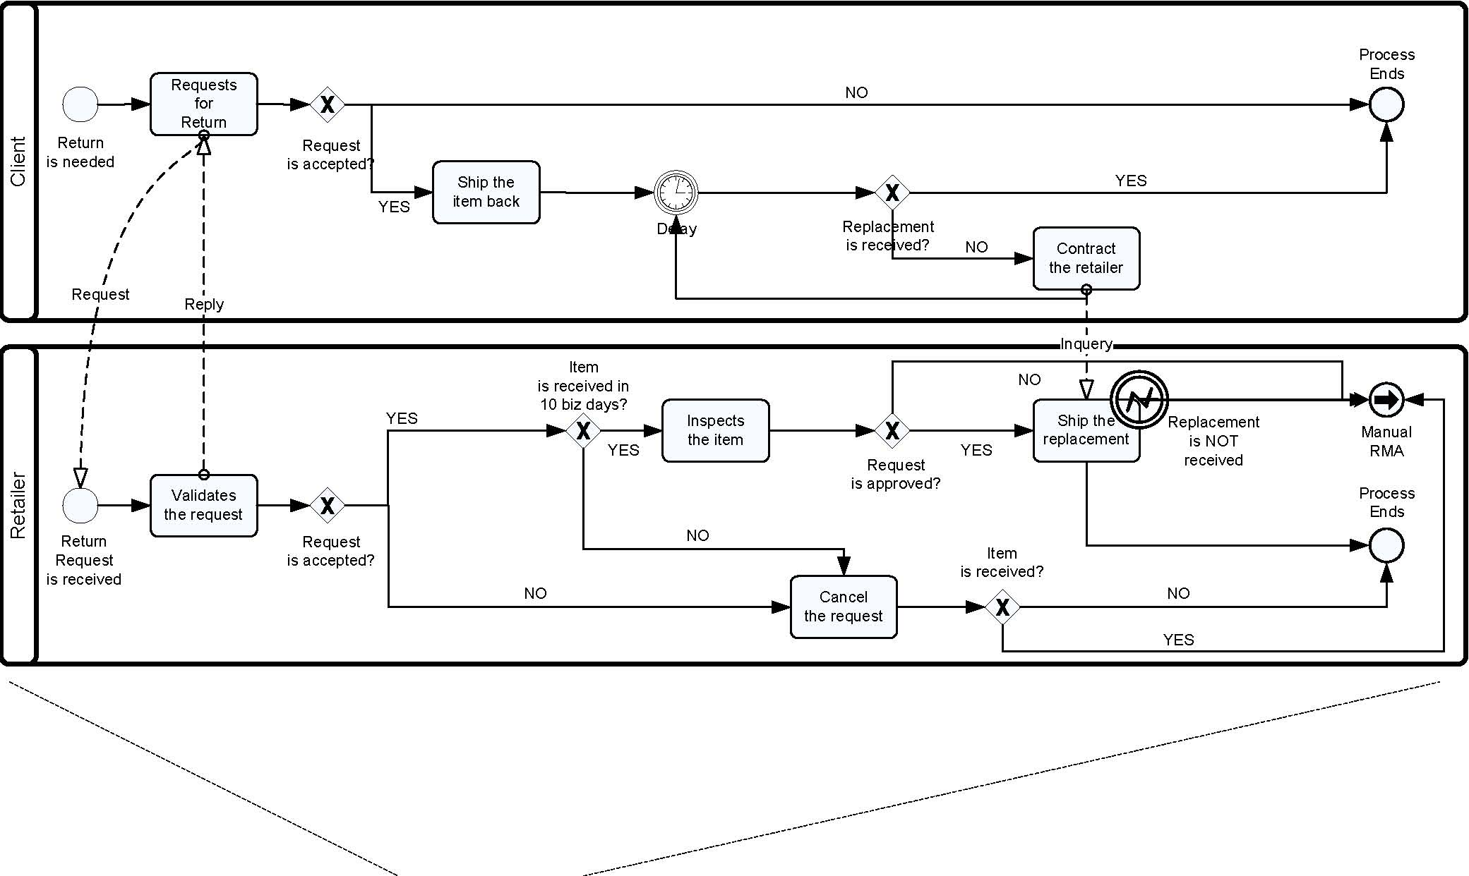

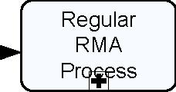RMA

RMA

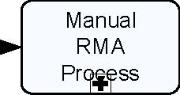

Ends

starts



